1. **Recognise LEAF from the given image by general Object recognition using OpenCV.**

**Aim:**

To recognize leaf from the given image by general object recognition using opencv.

**Code:**

import cv2

import numpy as np

import matplotlib.pyplot as plt

image = cv2.imread(r"C:\Users\prith\Documents\CV\cvimage.jpg")

gray = cv2.cvtColor(image, cv2.COLOR_BGR2GRAY)

blurred = cv2.GaussianBlur(gray, (5, 5), 0)

_, thresh = cv2.threshold(blurred, 60, 255, cv2.THRESH_BINARY_INV)

contours, _ = cv2.findContours(thresh, cv2.RETR_EXTERNAL, cv2.CHAIN_APPROX_SIMPLE)

leaf_contour = max(contours, key=cv2.contourArea)

cv2.drawContours(image, [leaf_contour], -1, (0, 255, 0), 3)

plt.figure(figsize=(10, 5))

plt.subplot(1, 2, 1)

plt.title('Original Image')

plt.imshow(cv2.cvtColor(image, cv2.COLOR_BGR2RGB))

plt.subplot(1, 2, 2)

plt.title('Threshold Image')

plt.imshow(thresh, cmap='gray')

plt.show()

**Input:**

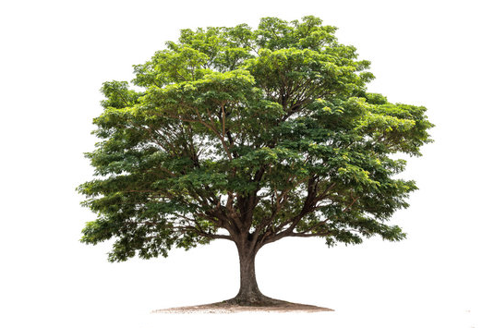

**Output:**

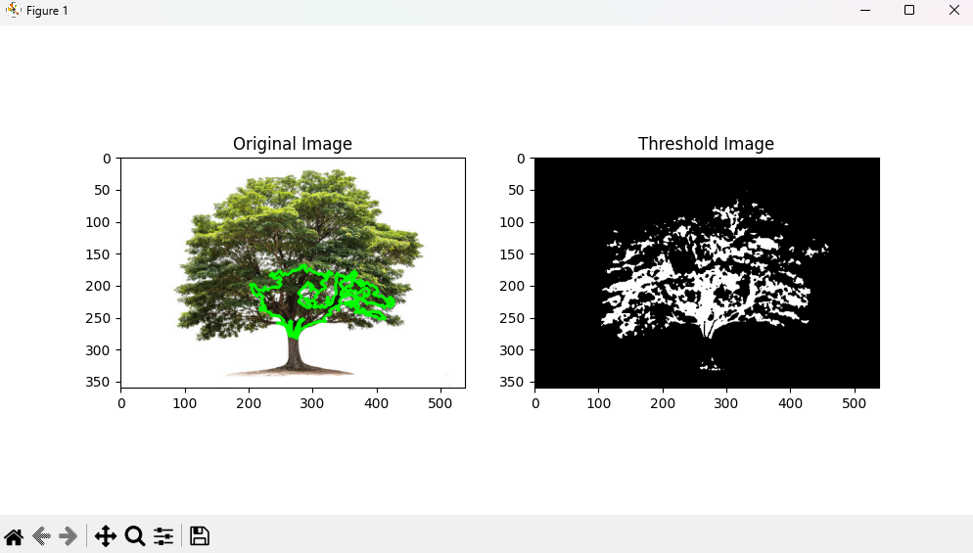

**Result:**

The python code to recognize leaf from the given image by general object recognition using opencv has been executed successfully.